Computing Coursework 2 – Solving engineering problems with a programming language
Name: Harry Hicks
Student ID: 20733567

Add the relevant parts to the various sections below. Once complete, add this document to the .git repository and submit it together with your code, text files and functions.

Task 1 – read temperature data, plot, and write to a log file
- Include a photograph of the implementation here.
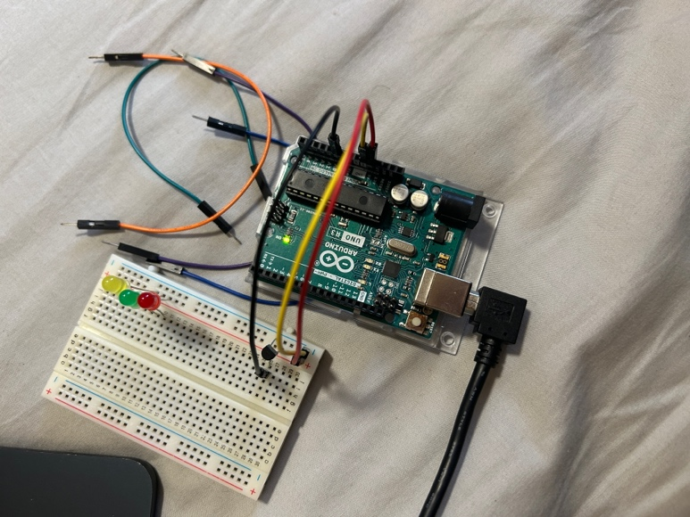
- Include the plot as an image here.
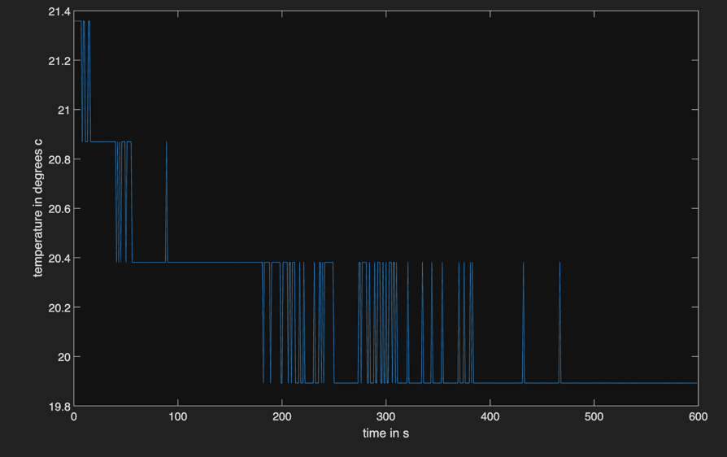

TASK 2 – LED temperature monitoring device implementation
- Include a photograph of the implementation here.
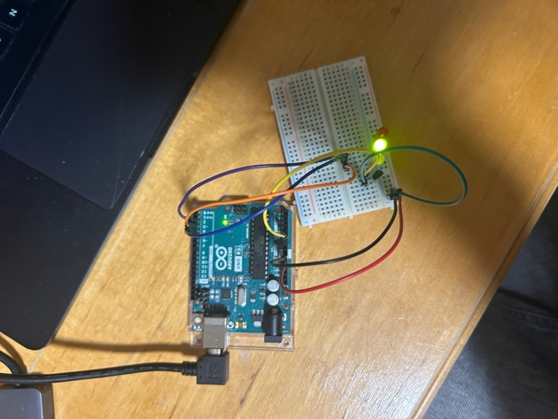
- Include your initial flowchart here.
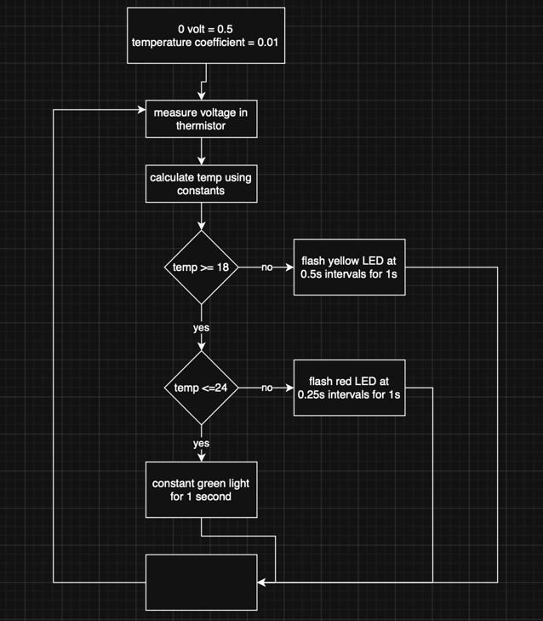
- Include the plot as an image here.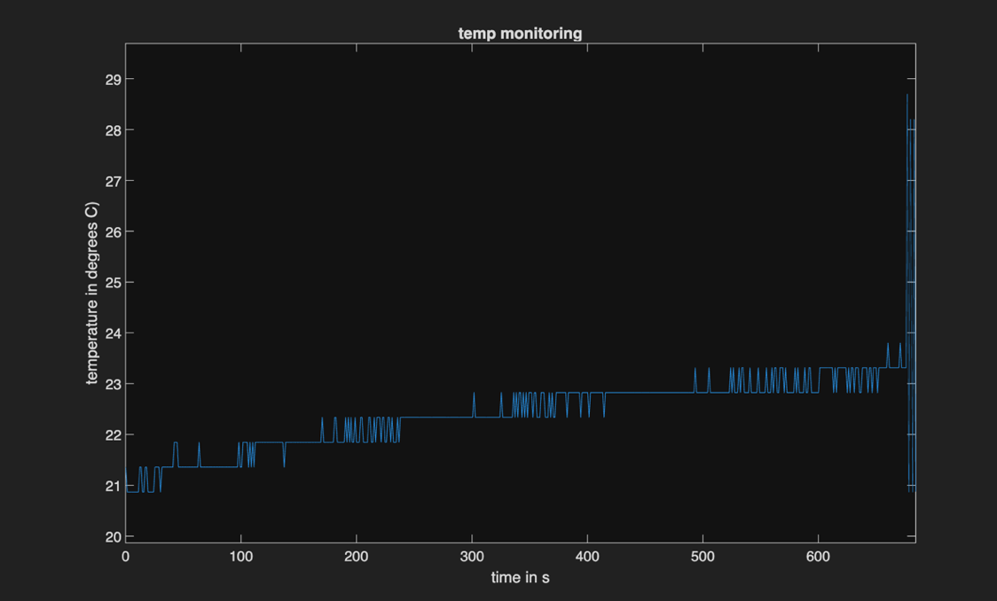
(knocked it at the end, which is why it massively spiked)
- Include your final flowchart here.
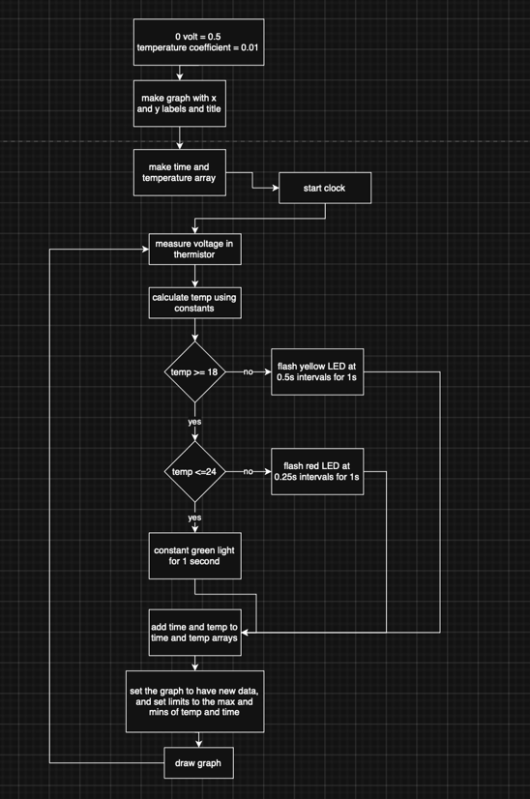

TASK 3 – ALGORITHMS – TEMPERATURE PREDICTION
- Include your initial flowchart here.
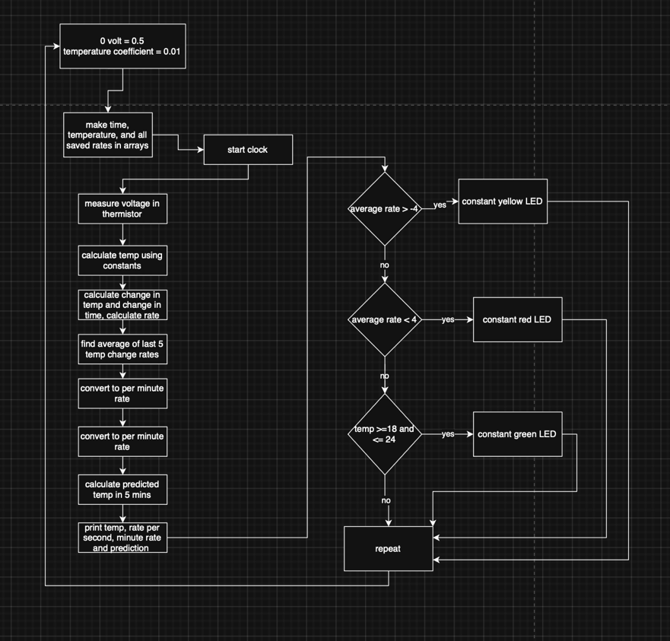

Task 4 – reflective statement
- Add your reflective statement here.
This coursework took a lot of work as some of the original methods of coding it didn’t work in practise. This meant that I had to do plenty of research to find other functions in this coding language to get it to work, for example, the tic and toc time functions. While I am proficient in Python, it took a minute for the new syntax to work its way into my head. By making sure I followed the tasks in order, I was able to utilise code from the preliminary and further tasks to make writing them quicker, as I had optimised them back there. The majority of the coding was common sense, the hardest bit was probably doing the documentation bit as the window that’s opened whenever you do the doc function command in console kept hiding itself, which confused me and took me a minute to troubleshoot.
Before this, I had never used a breadboard before. Part way through I was worried I had lost a few of the wires, because the method had used in the earlier tasks would result in needing more wires than supplied. I worked out I could just connect the components directly to the power/+/5V column on the breadboard, which finally allowed me to actually continue. I had to look up what each wire connected to the thermistor meant, and once I found that out, it was relatively simple to add it to the board, bending the wires to fit into respective power, ground and data rows. Due to doing multiple sessions of coding/adjustment, the port that I had for the Arduino kept changing, so I had to make sure, in every session, to plug the wires into the right slot in my USB connector, and that into the right USB-C slot in my laptop.

